Setup publish in vs2017

1. In the Deltavicore11.web_app=> right click=>publish
2. In publish dialog select ‘Create new profile’
3. 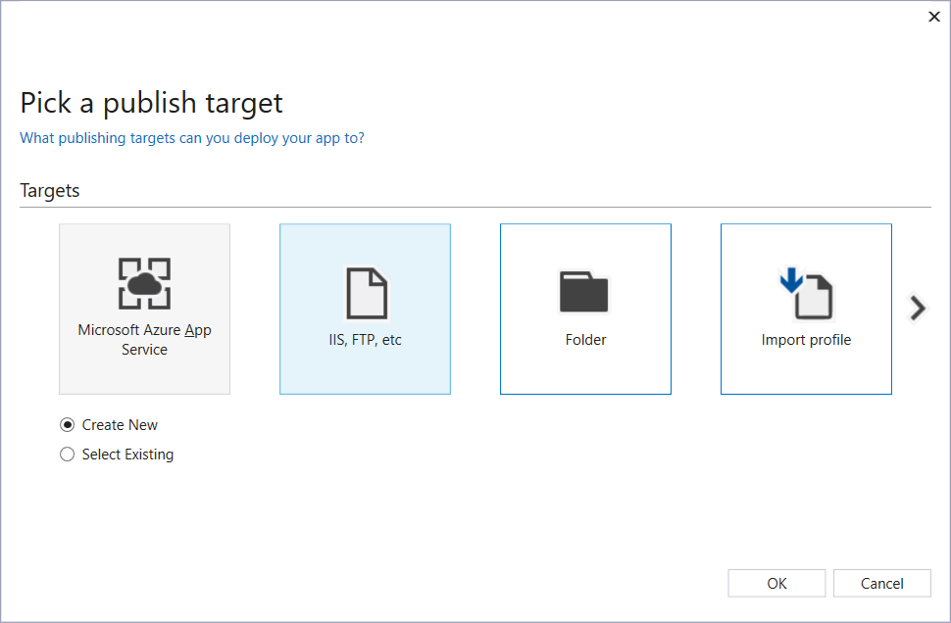

Select folder

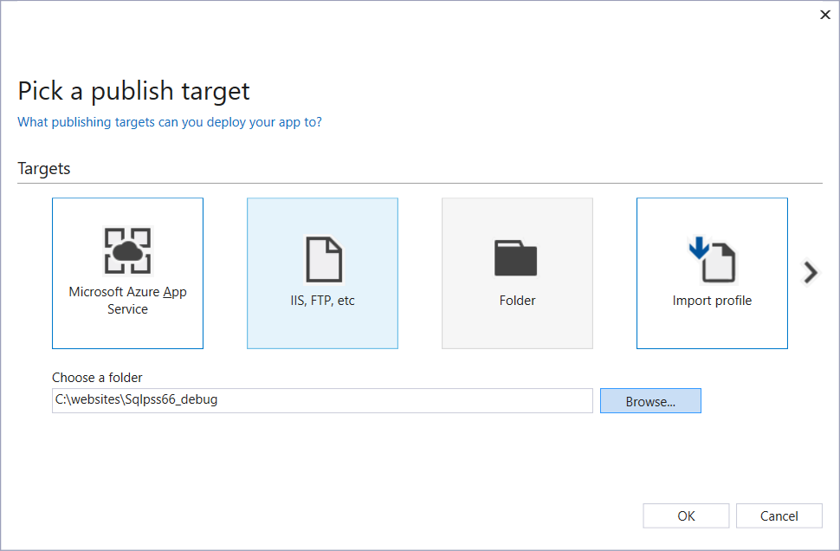

This folder, Sqlpss66_debug is a configuration build target

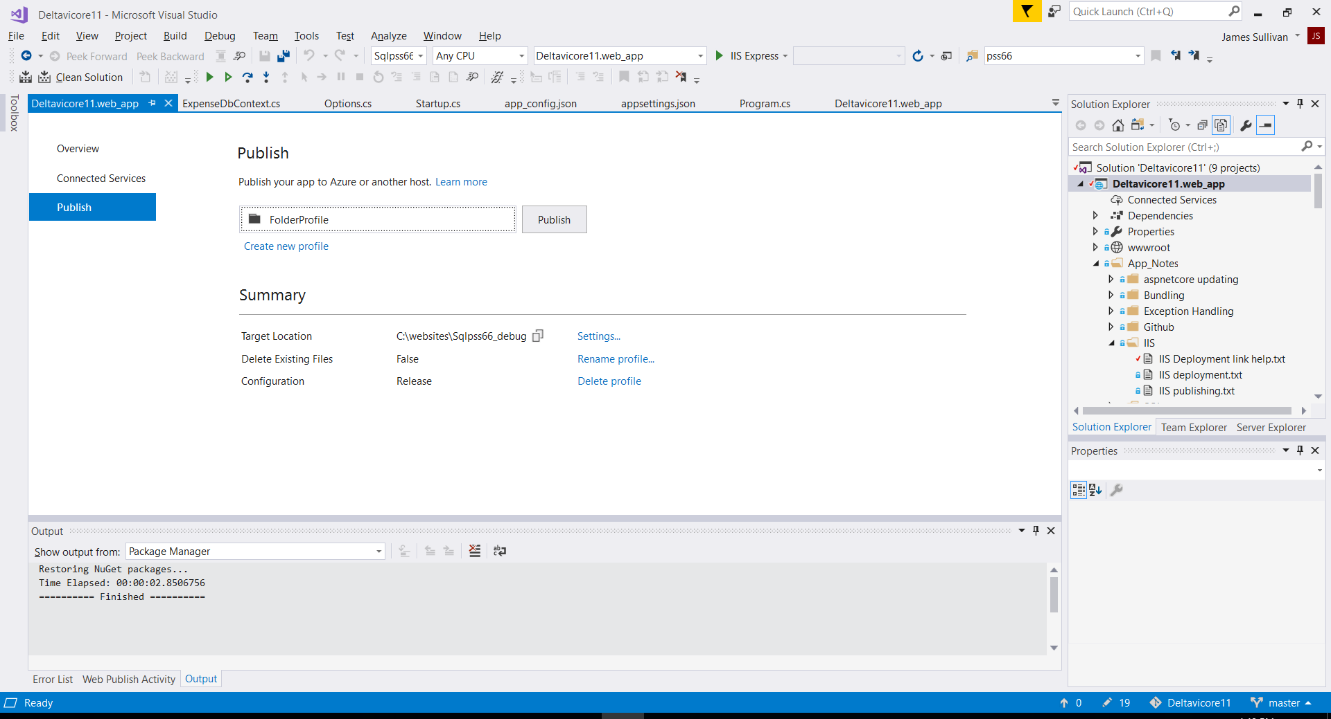

Click on rename profile enter Sqlpss66_debug

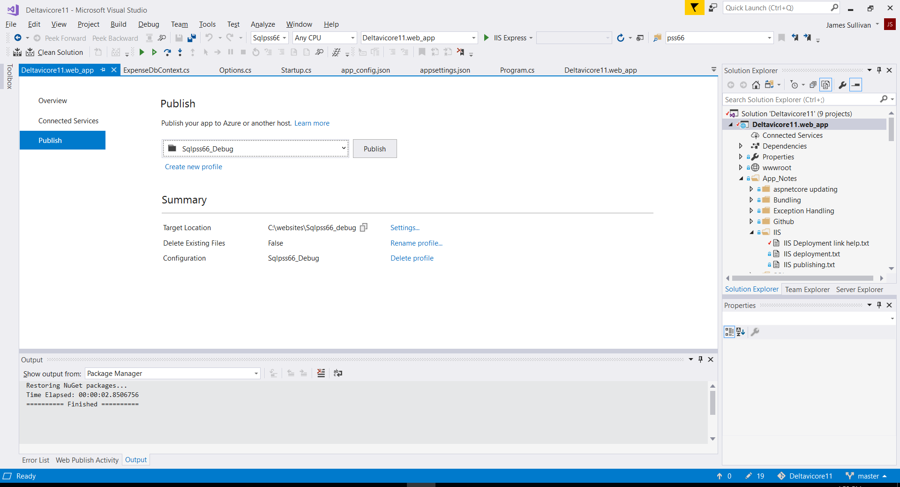

Select Target Location=> Settings

Nothing to change in next Publish Connection dialog

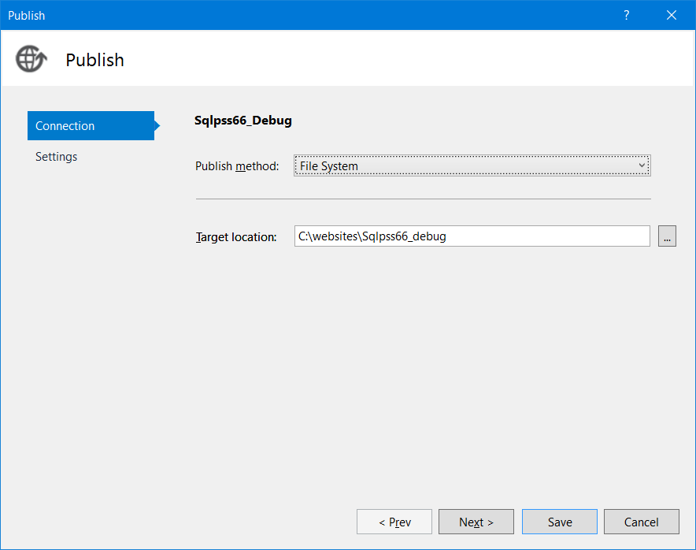

In Settings change Publish Settings => Configuration textbox to Sqlpss66_debug

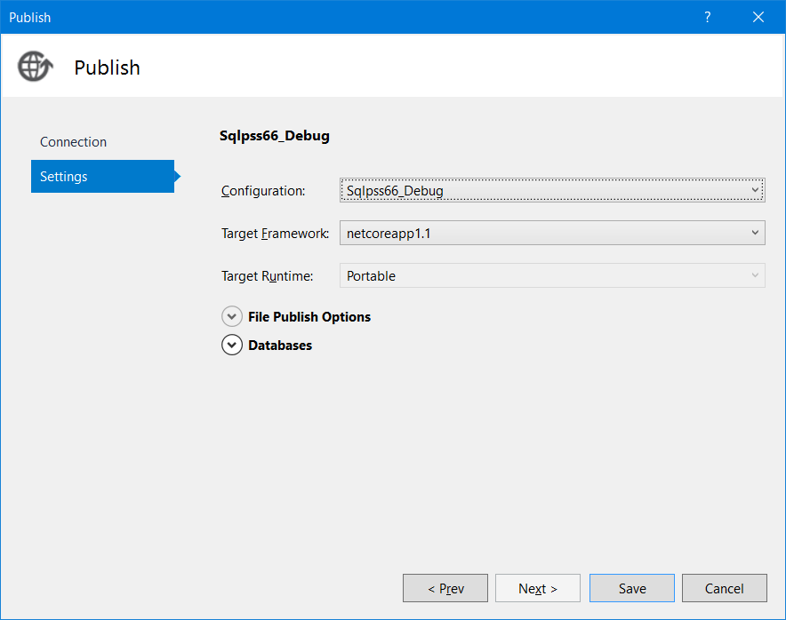

Set File Publish Options to ‘Delete all published files prior to publish’ to unchecked

Save all

***CLICK THE PUBLISH button***

The files built by vs2017 in C:\vwd projects mvc angular\Deltavicore11\Deltavicore11.web_app\bin\Sqlpss66_debug under Sqlpss66_debug configuration